Anomalous temperature and seasonality of chronic disease mortality in the United States

Overview
There is an ongoing debate as to how temperature deviations from long-term norms, expected under future climate change, will impact mortality, particularly for cardiorespiratory disease deaths.^{1–3} There is limited analysis on how monthly deviations of temperature from long-term norms will impact cardiorespiratory and other chronic diseases,⁴ especially in a consistent way across types of chronic disease death and demographic subgroups of the population. Here, I used data on chronic mortality and temperature over a 37-year period (1980-2016) in the entire contiguous United States. I formulated a Bayesian spatio-temporal model to estimate how anomalous temperatures affect deaths from different cardiovascular (ischaemic heart and cerebrovascular) and respiratory (COPD and respiratory infections) diseases, as well as cancers, by age groups and sex. I found that a 1°C anomalously warm year would be associated with an estimated 3100 (95% credible interval 2845-3357) fewer cardiorespiratory deaths in the contiguous United States. The reduction in deaths would mostly be concentrated in 55 years and over. Reductions in deaths would occur in all months except for June and July which would exhibit increases. Deaths from cancers show no consistent association with anomalous temperature. Sub-nationally, the most vulnerable states in January and July would be XX and XX, respectively. The findings add to the ongoing discussion and debate of how mortality burdens will change with the changing climate, indicating that while climate change has many claims to have a negative effect on society, it will potentially reduce the overall number of cardiorespiratory deaths in a warmer year.

Introduction
Temperature and mortality may be linked due to variation of death rates within the year. ⁵ As such, anthropogenic climate change has the potential to impact health, even in temperate regions of the world. Current assessments of climate change include impacts on cardiorespiratory deaths,^{6–11} due to well-established associations with changes in temperature.¹² While some studies predict some decrease in cardiorespiratory disease deaths under climate change,^{1,4,13,14} others argue otherwise.^{2,3} In the United States in 2016, cardiorespiratory diseases made up XX% of total deaths. Worldwide, the figure is similar, with XX%. As such, understanding of the dynamics of cardiorespiratory disease deaths therefore remains important in public health research and policy.
A lack of evidence exists about how changes in cardiorespiratory deaths will be distributed by type of cardiovascular and respiratory disease, age group, sex and month of the year.² There has also been little data on the potential association between deaths from cancers and anomalous temperature. Our aim was to evaluate how deaths from various chronic diseases, including deaths from cardiorespiratory disease and cancer, may be affected by changes in temperature that could arise as a result of global climate change in a national study.

Data

Overview of mortality data
I used vital registration data on all 79,689,529 non-injury deaths in the contiguous United States from 1980 to 2016 along with population records to calculate monthly death rates for each type of cardiorespiratory disease as well as cancers and other deaths, age group, sex and state combination. Of this, 41,105,009 were deaths from cardiorespiratory diseases, 19,862,760 were deaths from cancers, and 18,721,760 deaths were from causes other than cancers, cardiorespiratory diseases and injuries.
For each cardiorespiratory death, I mapped each ICD-9 and ICD-10 code to two cardiovascular (ischaemic heart disease, cerebrovascular) and two respiratory (Chronic obstructive pulmonary disease (COPD), respiratory infections) types of cardiorespiratory deaths. The remainder were from heterogeneous groups of ‘other cardiovascular diseases’ and ‘other respiratory diseases’, within each respectively the type of cardiovascular and respiratory disease that led to death varied by sex and age group. Causes of cardiorespiratory deaths within these groups include rheumatic, hypertensive and inflammatory heart diseases. I did not further subdivide cancer or other deaths. I obtained monthly population-weighted temperature from ERA-Interim. Full details of the data processing choices I made can be found in Chapter XX.

Cardiorespiratory disease deaths
20,070,797 boys and men and 21,034,212 girls and women died from cardiorespiratory diseases in the contiguous United States during 1980-2016. This accounted for 46.3% and 49.9% of all male and female deaths respectively (Figure XX in Chapter XX). 77.1% of male cardiorespiratory disease deaths and 88.7% of female cardiorespiratory disease deaths were in those aged 65 years and over (Figure 1). For females, 42.7% of female cardiorespiratory disease deaths were in those aged 85 years and over (Figure 1).
Deaths from ischaemic heart disease accounted for 45.3% of cardiorespiratory disease deaths in males and 38.7% in females (Figure 1). Males 25 years and above for and females 35 years died from ischaemic heart disease more than any other cardiorespiratory disease. The largest single proportion of ischaemic disease as a proportion of total cardiorespiratory deaths was in 45 to 54 year old men (52.1%). Below 25 years of age, respiratory infections were the largest single cause of cardiorespiratory disease death in both males and females.
There was a decline in age-standardised death rates of three out of four major cardiorespiratory disease (ischaemic heart disease, cerebrovascular disease and respiratory infections) for both men and women from 1980 to 2016. The largest and most dramatic overall decline over time was for ischaemic heart disease deaths, which declined by over 50% for both men and women from 1980 to 2016 (Figure 2), driving the overall reduction in cardiorespiratory deaths (Figure XX in Chapter XX). COPD deaths in males, while increasing from the 1980s until the late 1990s, have steadily decreased since then. The male age-standardised death rate for COPD contrasts with those of females, which have been steadily increasing since the 1980s (Figure 2). Age-standardised death rates for all cardiorespiratory diseases peaked in winter, as shown in my previous work highlighted in Chapter XX.⁵

Cancer and other deaths
In cancers, 10,428,202 boys and men and 9,434,558 girls and women died in the contiguous United States, accounting for 24.0% and 22.4% of all male and female deaths respectively (Figure XX in Chapter XX). Deaths from cancers accounted for 21.3% and 21.2% of total deaths in 1980, and 23.1% and 21.6% of total deaths in 2016, for males and females respectively, peaking in proportion of total deaths for males in the 1990s and 2000s then returning back to a lower value. Over time, death rates from cancers have decreased overall (Figure XX). There is limited evidence that cancer deaths are associated with anomalous temperature. The remainder of deaths were from other non-injury causes.
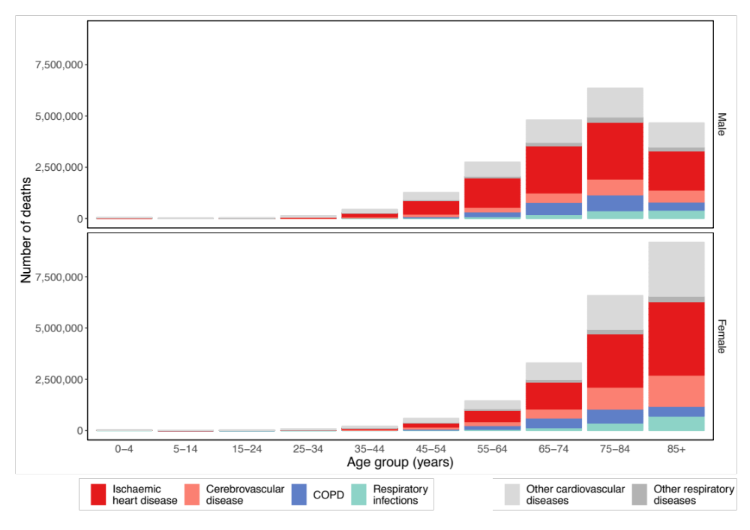
Figure 1. Number of cardiorespiratory disease deaths, by type of cardiovascular (ischaemic heart disease, cerebrovascular disease and other cardiovascular) and respiratory (COPD, respiratory infections and other respiratory) disease, by sex and age group in the contiguous United States for 1980-2016.
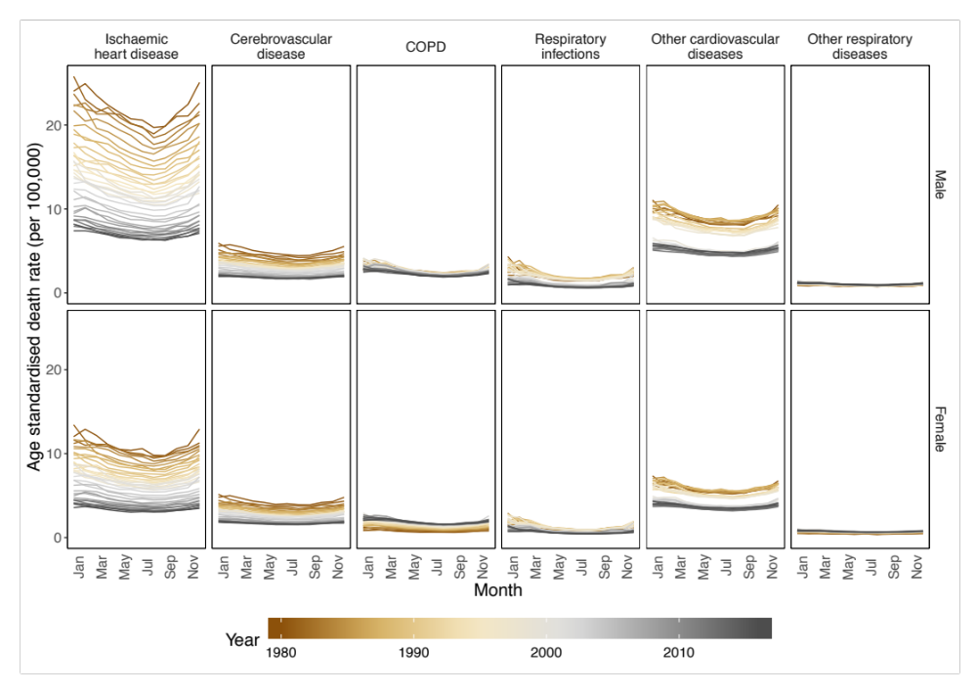
Figure 2. National age-standardised death rates from 1980 to 2016, by sex, cardiorespiratory disease and month

Statistical methods

National temperature model
I then analysed the association of monthly cardiorespiratory death rates with anomalous temperature using a Bayesian spatio-temporal model, described in Chapter XX. The model accounted for systematic variations in death rates across states and months, through state-, month- and state-month-specific random intercepts, and for their long-term trends. These terms together remove the effects of space and time varying factors other than temperature that affect injuries. Analyses were done separately by cardiorespiratory disease type, sex and age group. I used the resultant risk estimates and the age-sex-specific death rates from each cardiorespiratory disease type in 2016, to calculate additional deaths if each month in each state were +1°C above its long-term norm, by type of cardiorespiratory disease, sex, age group, state and month.
For each type of cardiorespiratory disease and cancer death, I calculated summaries of proportional changes in death by age and sex for all months (Figure 4) and by month for all ages (Figure 5) using 5000 posterior draws from the marginal of each month’s excess relative risk. My model design (Equation XX in Chapter XX) produced an excess risk for each combination of cardiorespiratory disease or cancer death, month, age groups and sex (Figure 8-Figure 14). I found no association between proportional change in deaths from cancers (Figure 14). I therefore did not include the results in further calculations. [[[Other deaths?]]]
I also ran a model where each state was given a separate temperature anomaly coefficient (Equation XX in Chapter XX), In this model, I used all cardiorespiratory diseases together. In Results, I present some results from this analysis. I used this to compare variations in association of anomalous temperature with cardiorespiratory disease deaths across states.

Results
Figure 3:
- Estimated 3100 (2845, 3357) fewer cardiorespiratory disease deaths, equivalent to XX% of all cardiorespiratory deaths in 2016.
- 56% of total reduction would be in males and 44% in females.
- Decrease in deaths in each cardiorespiratory disease type.
- Only increase in deaths in June/July/August.
- Reduction in deaths in colder months (November/December/January/February).
- 2506 (80.8%) of the total reduction in deaths would be from cardiovascular disease deaths (rest for respiratory diseases)
- 2993 (97%) of overall reduction would come from those aged 55 years and over.
- Largest single decease in ischaemic heart disease in females aged 85 years and over, at 371 (277,464).
- Across year, females generally doing worse than males as increase larger in summer months and decrease smaller in other months.
Figure 4:
- Proportionally, deaths from ischaemic heart disease are predicted to decrease more consistently than other cardiorespiratory diseases.
- Generally younger age groups (0 to 44 year olds) have wide uncertainty.
- Similar scale of proportional effect between males and females.
- Largest single reduction in 85+ years respiratory infections.
Figure 5:
- Similar profile across types of cardiorespiratory diseases and between sexes, with the exception of COPD in females.
- Decreases generally across all months except for summer months, where largest increase in ischaemic heart disease in July for both males and females.

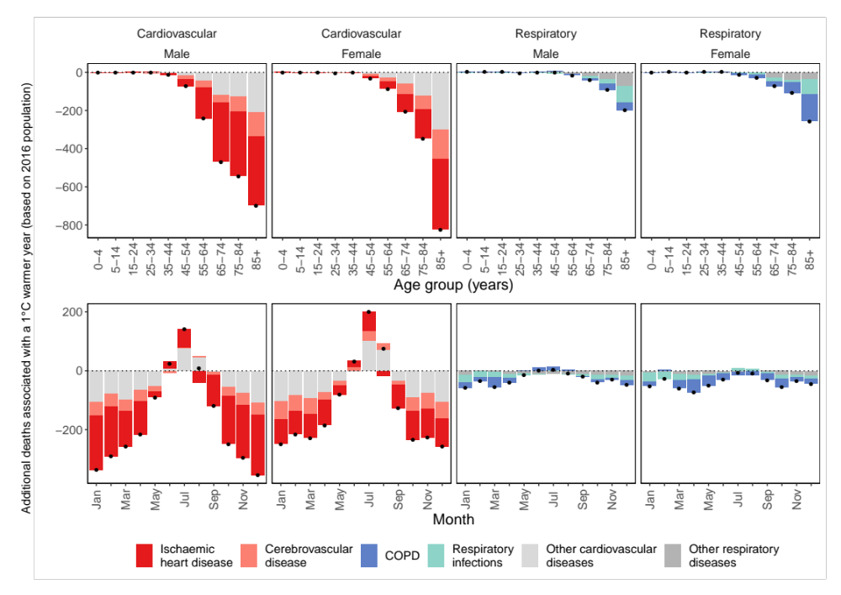
Figure 3. Additional annual cardiorespiratory disease deaths for the 2016 US population in year in which each month was +1°C compared with 1980-2009 norm temperatures. The top row shows breakdown by type of cardiorespiratory disease, sex and age group. The bottom row shows the break down by cardiorespiratory disease, sex and month. Black dots represent net changes in deaths for each set of bars.

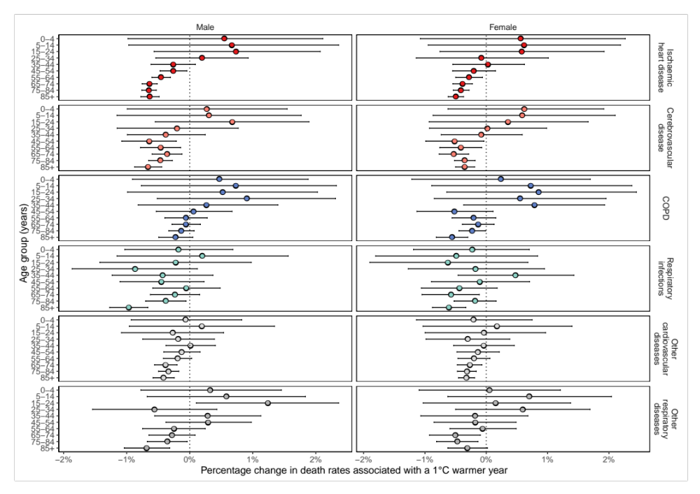
Figure 4. Percent change in death rates in year in which each month was +1°C compared with 1980-2009 norm temperatures by cardiorespiratory disease, sex and age group summarised across months.

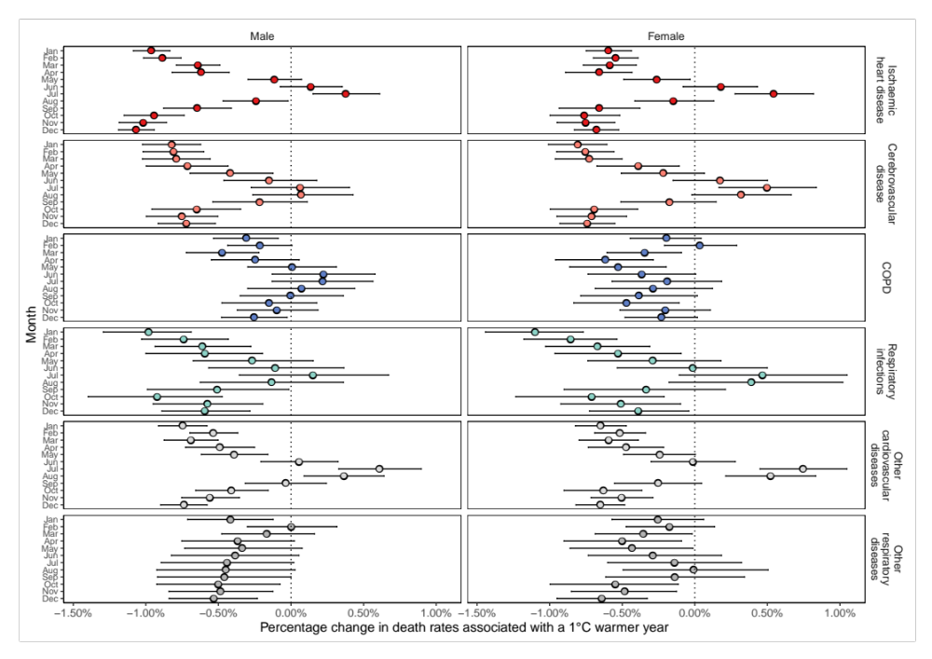
Figure 5. Percent change in death rates in year in which each month was +1°C compared with 1980-2009 norm temperatures by cardiorespiratory disease, sex and month summarised across age.

Subnational temperature model
Figure 6 and Figure 7 (replace with ranking perhaps?)
- Ranking of states important [[[Figure out results]]]
- Argument that the similarity of relative risk shapes justifies using all cardiorespiratory deaths as a proxy
- Centred well with national model.
Maps of rankings
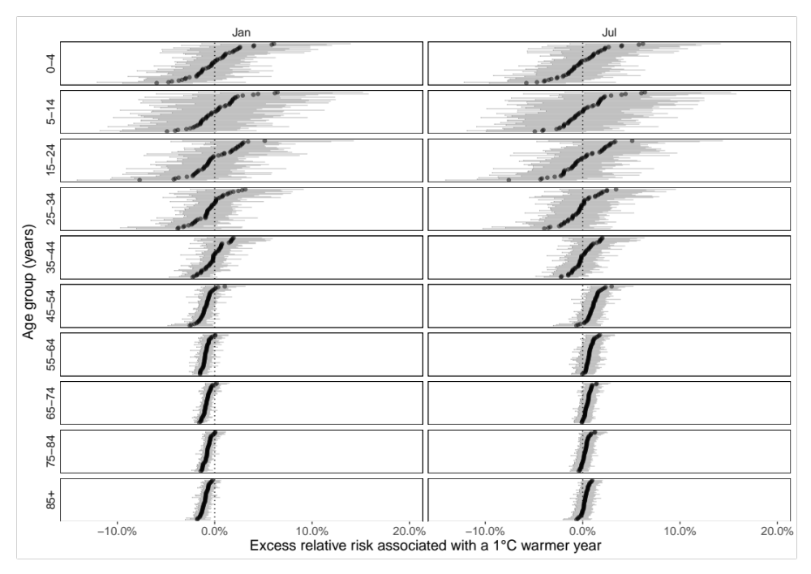
Figure 6. Excess relative risk for males in January and July in cardiorespiratory disease death rates in year in which each month was +1°C compared with 1980-2009 norm temperatures by state and age group.
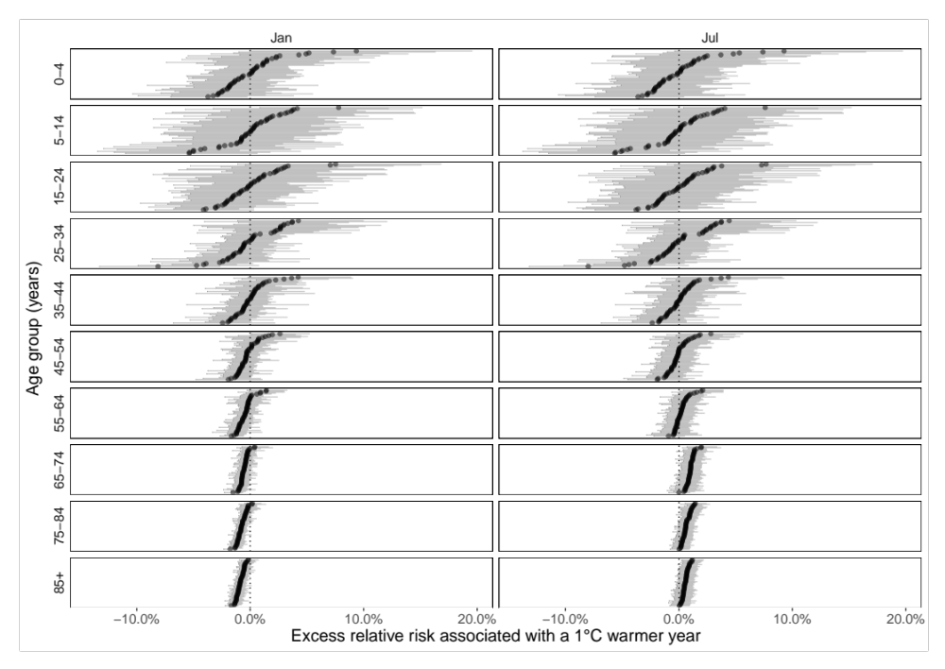
Figure 7. Excess relative risk for females in January and July in cardiorespiratory disease death rates in year in which each month was +1°C compared with 1980-2009 norm temperatures by state and age group.
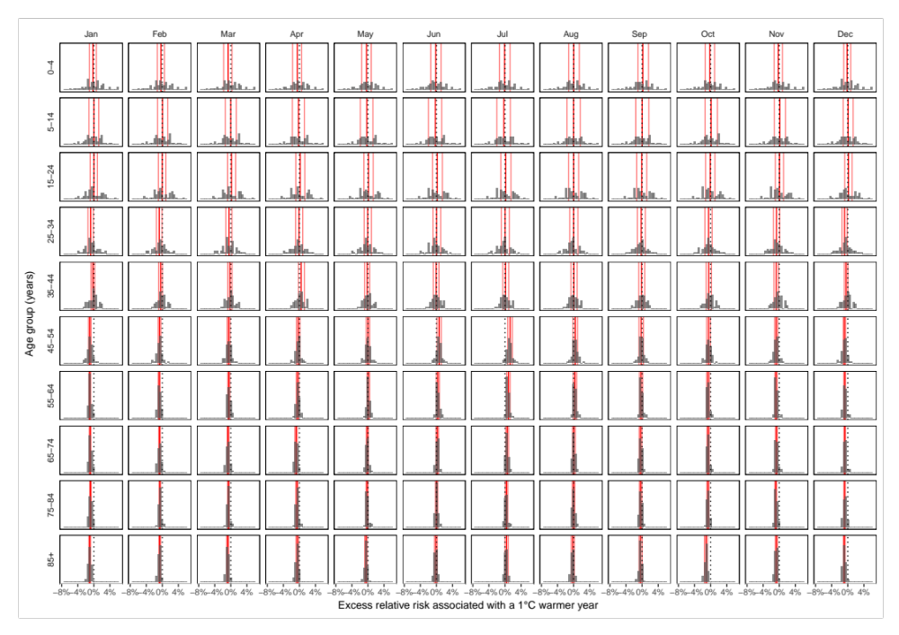
Figure 8. Histograms of excess relative risk for males in January and July in cardiorespiratory disease death rates in year in which each month was +1°C compared with 1980-2009 norm temperatures by state and age group.
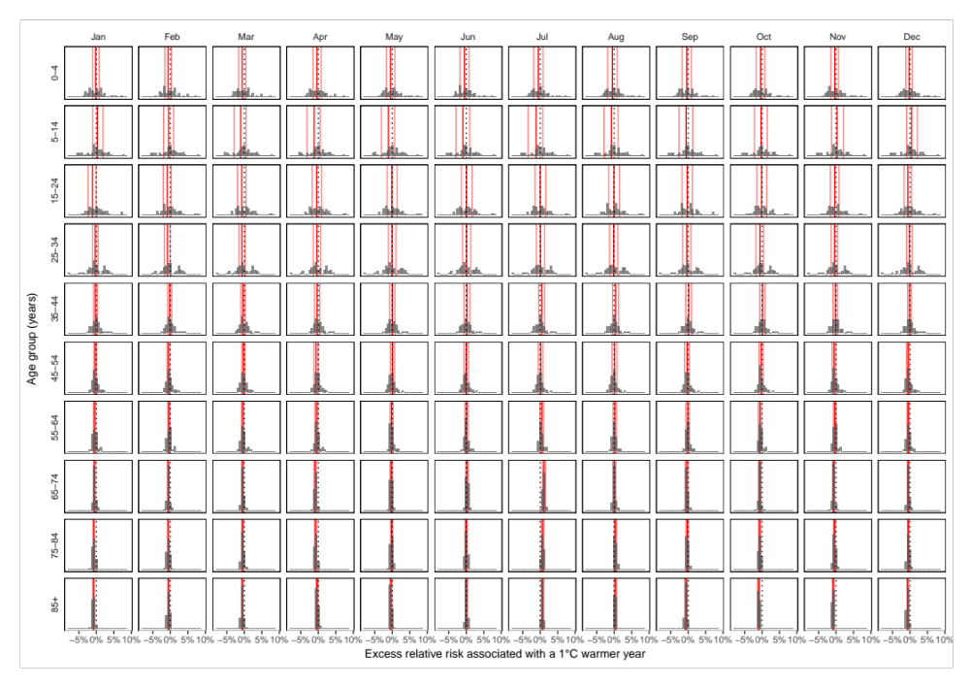
Figure 9. Excess relative risk for males in January and July in cardiorespiratory disease death rates in year in which each month was +1°C compared with 1980-2009 norm temperatures by state and age group.

Summary
- How well do results agree with previous ones?
- Paragraph for each of the 4 causes
- Major strengths of study?
- Why work is important?
- What to say about reduction in context of climate change still being bad?


Figure 10. Excess relative risk in ischaemic heart disease death rates in year in which each month was +1°C compared with 1980-2009 norm temperatures by month, sex and age group.

Figure 11. Excess relative risk in cerebrovascular disease death rates in year in which each month was +1°C compared with 1980-2009 norm temperatures by month, sex and age group.

Figure 12. Excess relative risk in COPD death rates in year in which each month was +1°C compared with 1980-2009 norm temperatures by month, sex and age group.

Figure 13. Excess relative risk in respiratory infection death rates in year in which each month was +1°C compared with 1980-2009 norm temperatures by month, sex and age group.

Figure 14. Excess relative risk in other cardiovascular disease death rates in year in which each month was +1°C compared with 1980-2009 norm temperatures by month, sex and age group.

Figure 15. Excess relative risk in other respiratory disease death rates in year in which each month was +1°C compared with 1980-2009 norm temperatures by month, sex and age group.

Figure 16. Excess relative risk in cancer death rates in year in which each month was +1°C compared with 1980-2009 norm temperatures by month, sex and age group.

Figure 17. Excess relative risk in death rates from causes other than cancers, cardiorespiratory diseases and injuries in year in which each month was +1°C compared with 1980-2009 norm temperatures by month, sex and age group.

Works cited
1 Kinney PL, Schwartz J, Pascal M, et al. Winter season mortality: Will climate warming bring benefits? Environ Res Lett 2015; 10. DOI:10.1088/1748-9326/10/6/064016.
2 Ebi KL, Mills D. Winter mortality in a warming climate: A reassessment. Wiley Interdiscip Rev Clim Chang 2013; 4: 203–12.
3 Staddon PL, Montgomery HE, Depledge MH. Climate warming will not decrease winter mortality. Nat Clim Chang 2014. DOI:10.1038/nclimate2121.
4 Shi L, Kloog I, Zanobetti A, Liu P, Schwartz JD. Impacts of temperature and its variability on mortality in New England. Nat Clim Chang 2015; 5: 988–91.
5 Parks RM, Bennett JE, Foreman KJ, Toumi R, Ezzati M. National and regional seasonal dynamics of all-cause and cause-specific mortality in the USA from 1980 to 2016. Elife 2018; 7. DOI:10.7554/eLife.35500.
6 Watts N, Amann M, Arnell N, et al. The 2018 report of the Lancet Countdown on health and climate change: shaping health of nations for centuries to come. Lancet 2018; 6736: 1–4.
7 McMichael AJ, Woodruff RE, Hales S. Climate change and human health: Present and future risks. Lancet. 2006. DOI:10.1016/S0140-6736(06)68079-3.
8 Huang C, Barnett AG, Wang X, Vaneckova P, Fitzgerald G, Tong S. Projecting future heat-related mortality under climate change scenarios: A systematic review. Environ. Health Perspect. 2011. DOI:10.1289/ehp.1103456.
9 Gasparrini A, Guo Y, Sera F, et al. Projections of temperature-related excess mortality under climate change scenarios. Lancet Planet Heal 2017. DOI:10.1016/S2542-5196(17)30156-0.
10 Smith KR, Woodward A, Campbell-Lendrum D, et al. Human health: Impacts, adaptation, and co-benefits. In: Climate Change 2014 Impacts, Adaptation and Vulnerability: Part A: Global and Sectoral Aspects. 2015. DOI:10.1017/CBO9781107415379.016.
11 Haines A, Ebi K. The imperative for climate action to protect health. N Engl J Med 2019; : 263–73.
12 Gasparrini A, Guo Y, Hashizume M, et al. Mortality risk attributable to high and low ambient temperature: A multicountry observational study. Lancet 2015; 386: 369–75.
13 Hajat S, Gasparrini A. The excess winter deaths measure: Why its use is misleading for public health understanding of cold-related health impacts. Epidemiology 2016. DOI:10.1097/EDE.0000000000000479.
14 Ballester J, Rodó X, Robine J, Herrmann FR. European seasonal mortality and influenza incidence due to winter temperature variability. Nat Clim Chang 2016; 6: 6–10.

Some of the contents of this chapter are in a paper which is currently being prepared for submission.

